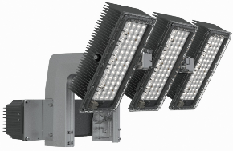
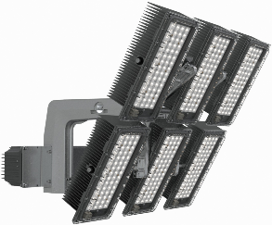
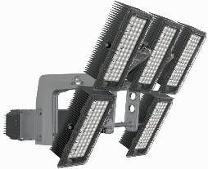
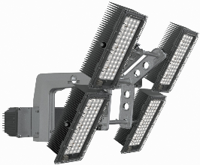

ECOBLAST
External tender text – 30/03/2021

CONCEPT
The ECOBLAST is an innovative high-performing floodlight that has been designed to offer an outstanding combination of performance and flexibility for lighting sports venues and other large areas where high lumen packages are needed (system up to 240klm initial). It is the ideal replacement for 1000W, 1500W and 2000W discharge lamps.
The ECOBLAST is ideal for lighting all large outdoor areas such as recreational and professional sports fields, airports, ports and railway stations. Indoor applications are also possible.

The modular concept of optical units which enables several modules to be grouped on the same bracket and the performing BlastFlex®4 & LensoFlex®4 LED engines means that the ECOBLAST provides a wide range of lighting distributions and lumen packages to meet the specifications of the area to be lit, even the most complex projects.

The ECOBLAST offers a perfect control of the light, which minimises glare and light pollution. External accessories such as a hood and a louvre are also available when the lighting design needs to be optimised. Its high lighting levels (horizontal and vertical) ensure compliance with sports federations and international regulations. Dynamic DMX lighting is also available as an option.

The ECOBLAST has been designed to integrate retrofit projects (existing infrastructure such as pool or roof structure) without compromising the supports. Its modular architecture and its low wind resistance remove any additional mechanical stress. The wireless communication module does not require the installation of new additional cables.

HOUSING & FINISH
- Weight: from 17.1kg (remote driver box) to facilitate the installation and not overload the existing structure
- Housing in anodised extruded aluminum modules and LM6 fork for maximum corrosion resistance
- Protector: thermally hardened glass or polycarbonate
- Tightness
  - optical: IP 66
  - driver: IP 66
- Impact resistance: IK 09 (PC) / IK08 (Glass) + Ball throwing test

INSTALLATION
- Standard base plate for direct fixation
- Individual adjustment of the 2 rows of optics coupled with the adjustment of the main support. This can be done on the ground via a graduated scale (5°) on the basis of the photometric study carried out beforehand
- Aiming device holder (laser pointer, scope or innovative digital camera)
- Pre-wired LED modules connected to the driver
- Remote driver box up to 200 metres
- Wireless control (scenes, dimming, and personalisation via the Schréder Lighting Management System) (no rewiring needed for existing installations)

OPTICAL UNIT
- Available in 3, 4, 5 and 6 modules (up to 240klm) to provide great flexibility and a perfect adaptation to the most complex project
- Asymmetrical photometry for a better control of light pollution and glare while guaranteeing high performance results (lighting levels and uniformity) (symmetrical photometry available as an option)
- Circular-economy ready: on-site optical unit replacement, which is enclosed in the housing with a removable gasket
- Photometric performance maintained by using a 4mm thick extra-clear tempered glass closure or 3.5mm UV-resistant polycarbonate (PC).
- Neutral white (NW) (4000K), Cold white (CW) (5700K), Warm white (WW) (3000K)
- Flatbed (PCB) with ATUGLASS lens overlaying principle with vacuum soldering of LEDs to cater for large temperature variations
- Current range from 1.25A to 1.68A
- CRI/CCT 740 & 757 (CRI 80 and 90 available as an option)
- TLCI (Television Lighting Consistency Index) up to 97 depending on the CRI

LED LUMEN DEPRECIATION
- Temperature range from -40°C to +50°C
- Lifetime residual flux @ Tq=20°C
L96 @ 50.000hrs

SMART-READY
- Wireless & Intelligent control solutions (Schréder ITERRA) to ensure comfort, safety, and an effective energy management. This includes, dimming, scenarios, scheduling, and many more.

ELECTRICAL
- Nominal input voltage: 220-240/277/347/400 VAC
- Power factor > 95% at full load
- Optimised In-rush current
- Extremely low current ripple: IEEE 1789 Flicker Recommended Practice Compliant
- DALI (DMX available in option)
- Class I
- Harmonics THD < 15%
- 10kV surge protection

STANDARDS & CERTIFICATIONS
- CE
- ENEC
- ENEC+ (on going)
- LM79-80
- cSGSus for NA & CAN certification (on-going
- ROHS
- RCM
- IEEE 1789 Flicker Recommended Practice Compliant
- DIN 18032-3 / DIN EN 13964 Ball Throwing test
- Circle Light passport
- All measurements are made in ISO17025 accredited laboratory

OPTIONS
- CRI/CCT: 840, 957, 730
- Symmetrical distribution
- Glass protector
- DMX-RDM dimming for theatrical & entertainment effects
- Glare control accessories: hood, louvres
- Camera-based aiming device with archiving function for reporting
- Schréder ITERRA

SUMMARY
SPECIFICITIES | ECOBLAST  6 modules | ECOBLAST  5 modules | ECOBLAST  4 modules | ECOBLAST  3 modules
Number of modules | 6 | 5 | 4 | 3
Weight (PC protector - without driver) | 32.3kg | 29kg | 25.2kg | 17.1kg
Driver weight (included or deported) | 6kg  (+1.5kg to attach it on the luminaire)
Driver used | 1.8kW (3 channels) | 1.8kW (3 channels) | 1.2kW (2 channels) | 1.2kW (2 channels)
Power consumption | 1.82kW | 1.52kW | 1.21kW | 910W
Ta/Tq | Indoor: 40°C / 30°C @ 86% Power (up to 1.45A)  Outdoor: 50°C / 25°C @ 95% Power (up to 1.6A)  Outdoor: 45°C / 20°C @ 100% Power (up to 1.68A)
Led flux @ Tq 20°C | 240 klm @ 1.68A | 200 klm @ 1.68A | 160 klm @ 1.68A | 120 klm @ 1.68A
Inrush current | 240V - 26A – 6.8ms  400V -20A – 1.5ms |  | 220V – 26A – 6.4ms  400V – 20A – 4.7ms
CxS worst value | 0.297  (lab measure) | 0.282 (simulation) | 0.252  (simulation) | 0.219  (simulation)
Dimensions (mm) | 696x765 | 696x765 | 696x765 | 696x583

CXS DETAILS
Tilting / OB# | 6 modules  (lab measure) | 5 modules  (simulation) | 4 modules  (simulation) | 3 modules  (simulation)
70° | 0.297 | 0.282 | 0.252 | 0.208
60° | 0.276 | 0.265 | 0.24 | 0.207
40° | 0.242 | 0.235 | 0.215 | 0.194
30° | 0.244 | 0.239 | 0.222 | 0.207
10° | 0.232 | 0.23 | 0.216 | 0.209
0° | 0.231 | 0.231 | 0.219 | 0.219

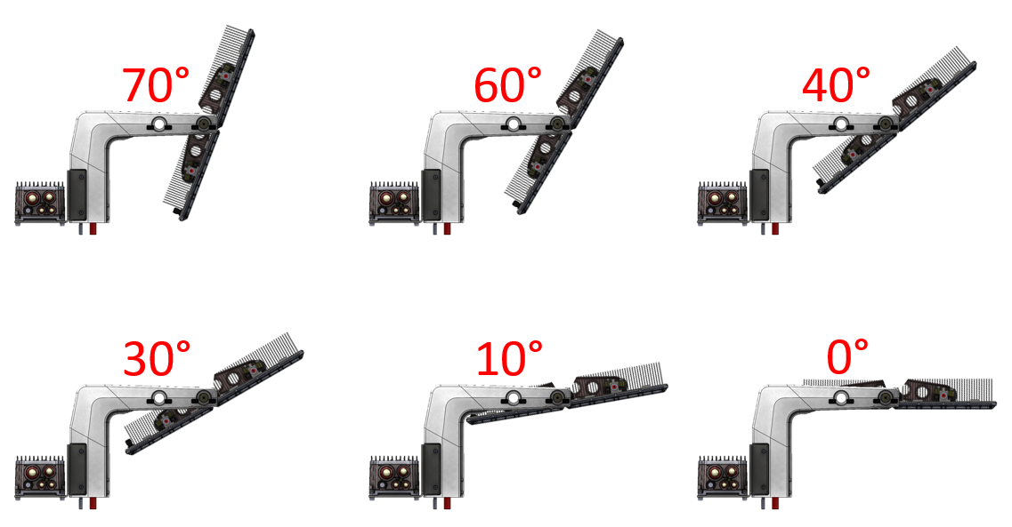

PHOTOS
6 modules:

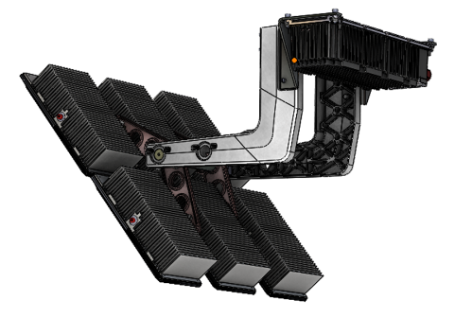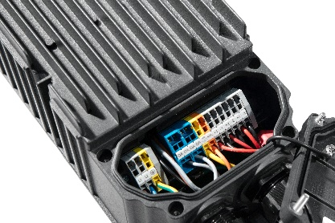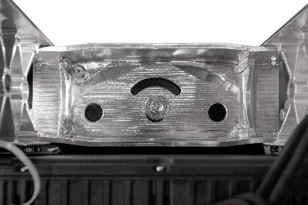
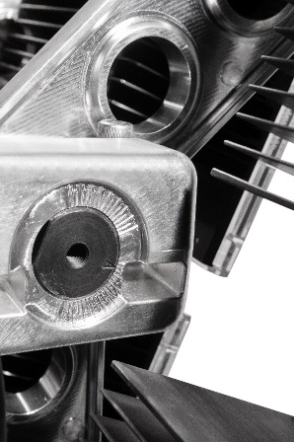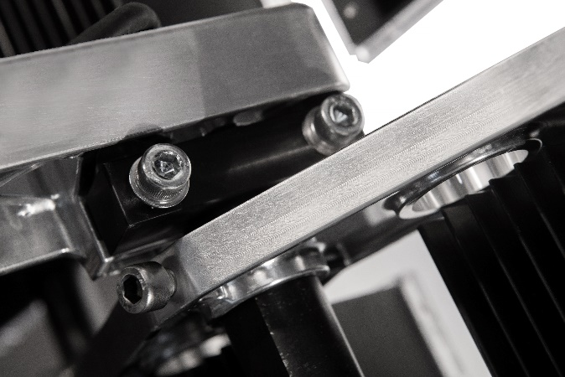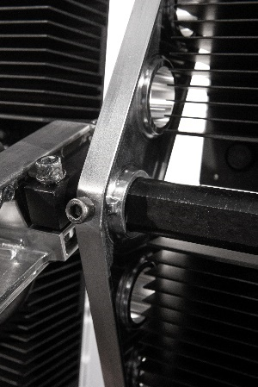

5 modules:
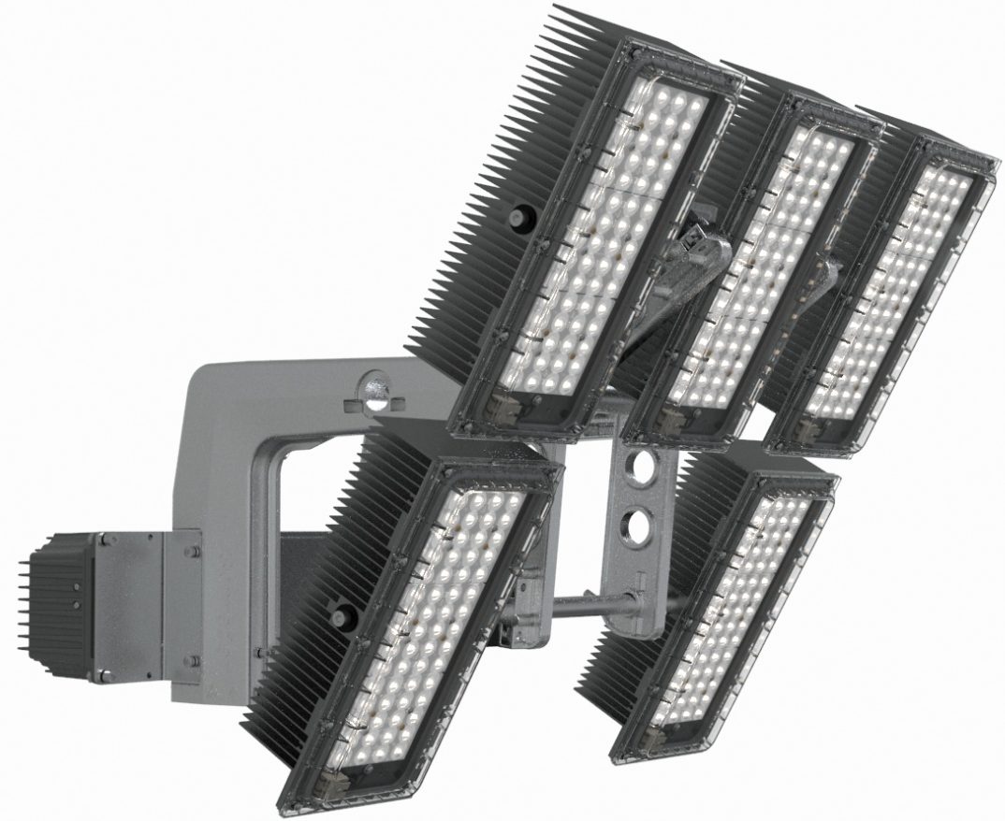

4 modules:
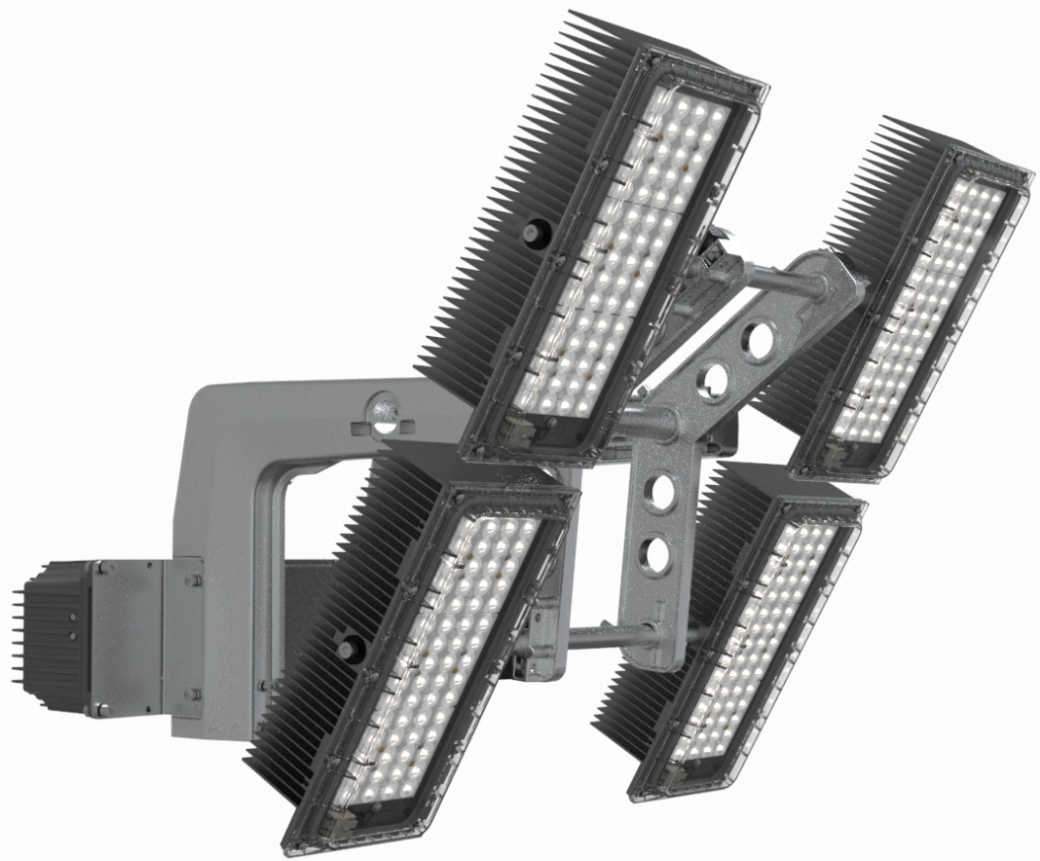

3 modules:
